Invitation to
Anniversary Spring Field Trial in Denmark

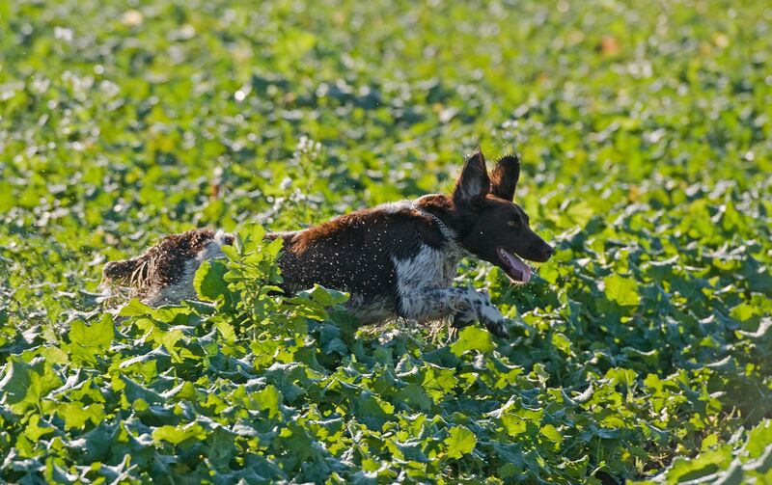
The Danish Münsterländer Club will this year celebrate its 50 year anniversary with a span of exiciting activities.
The spring field trials will be held in the beautiful area of Ballum close to the Northsea in the south-west of Denmark. Ballum is known and famous for its large and wild population of grey partridige and pheasants.
Saturday evening there will be a Spring Anniversary “Münster” Party.
Both Groβer and Kleine Münsterländer are welcome to join. Rules for the Danish field trials can be found at http://www.danskjagthundeudvalg.dk/images/stories/PDF/2013.11.21_FMR_ENGELSK.pdf

Schedule for the weekend
Saturday
- Youth Class (10-24 months) and Open Class
Sunday
- International Winner Class
- UT (Youth Trial Test) the same as the German VJP.
- Open Class
Meeting point and time both days: Ballum Multihus, Vestervej 10B, 6261 Bredebro.
Latest arrival 8.00 am with departure to the fields 8.30. Breakfast from 7.30 am.
IMPORTANT: Registration for all classes on the Danish webpage www.hundeweb.dk. Registration date 21st of March. Charge of fee per Class 350 DKK. Rules for Field Trials in English can be found here: http://www.danskjagthundeudvalg.dk/images/stories/PDF/2013.11.21_FMR_ENGELSK.pdf
Catering - saturday
Complete cartering including banquet saturday evening 375 DKK forplejning lørdag incl. festmiddag 375 kr. The complete catering consist of breakfast, lunch + 1 bier/soft drink, afternoon coffee with buns and cake and 3 dishes banquet in the evening.
Catering without banquet 165 DKK consist of breakfast, lunch + 1 bier/soft drink, afternoon coffee with buns and cake.

Catering - sunday
Complete catering for UT/VJP and open class participants’ incl. breakfast, lunch package and afternoon coffee 115 DKK
Complete catering for International Winner Class incl. breakfast, lunch and afternoon coffee 165 DKK

Spring “Münster” Party
Saturday evening the anniversary year will be celebrated with all participants in Ballum Multihus. In the Danish Münsterländer Club we have a strong social atmosphere between members and guests. Please join this fantastic evening. Wine, soft drinks and biers can be bought to favorable prices.
IMPORTANT: Registration for all classes on the Danish webpage www.hundeweb.dk. Registration date 21st of March. Charge of fee per Class 350 DKK. Rules for Field Trials in English can be found here http://www.danskjagthundeudvalg.dk
For any questions please feel free to contact the trial administrator Peter Katholm 0045 21 34 16 60 or at email katholm@privat.dk

